

**PROJECT ON:Simple calculator**

**SUBMITTED TO: Ms. Jyoti Yadav**

**SUBMITTED BY:**

**Dhruv Tyagi(23csu099)**

**Deepanshu Yadav(23csu091)**

**Dhruv Chavda(23csu096)**

**Dhyanesh Sharma(23csu100)**

**INDEX**

* Problem statement
* Flowchart
* Algorithm
* Output Screenshots
* References
* Future Scopes
* Code

***PROBLEM STATEMENT*:**

Build a calculator program that can allow user to select specific arithmetic operations from the menu provided by the program. Initially, this program will display a main menu to choose the calculator operations.

In our calculator, users are able to select the option for addition, subtraction, division, multiplication, square root, cube root and exponents.

**Display calculator options**

**Read A and B**

**Switch**

**Case 1:**

**Case 2:**

**Case 7:**

**Case 3:**

**Case 4:**

**Case 5:**

**Case 6:**

**Default**

**SUBTRACT**

**MULTIPLY**

**DIVIDE**

**SQUARE ROOT**

**EXPONENT**

**CUBE ROOT**

**ADD**

Y

**N**

Y

**N**

Y

**N**

Y

**N**

Y

**N**

Y

**N**

Y

**N**

***FLOWCHART***

***ALGORITHM***

* **Start the Program**
* **Display a Welcome Message and instructions for using the Calculator**
* **Ask for the operation to perform (Add, Subtract, Divide, Multiply, Square Root, Cube Root, Exponents)**
* **Read the Numbers from the user**
* **Display the result to the user**
* **Stop the program**

***OUTPUT SCREENSHOTS***

***Addition:***

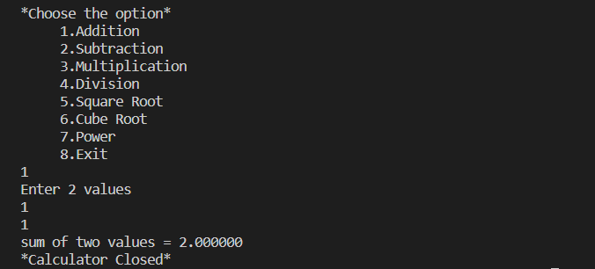

***Subtraction:***

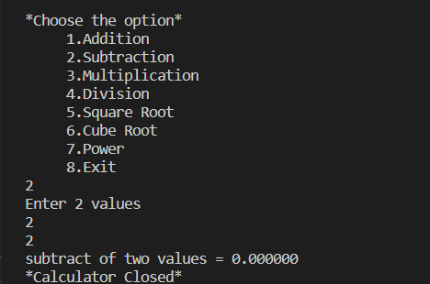

***Multiplication:***

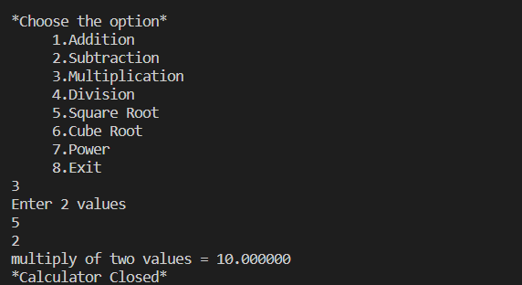

***Division:***

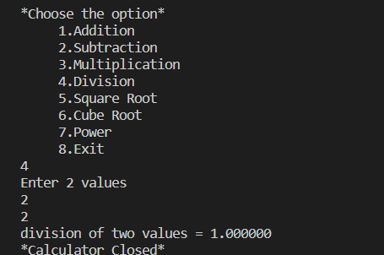

***Square Root:***

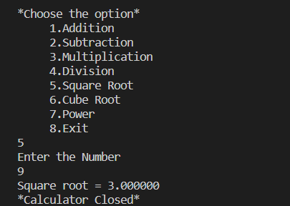

***Cube Root:***

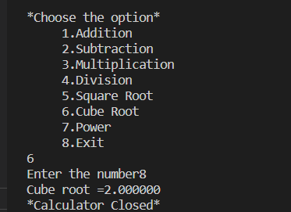

***Power:***

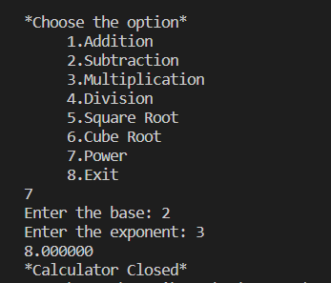

***Exit:***

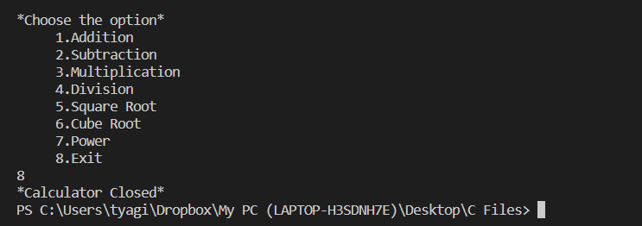

***REFERENCES***

[***https://www.programiz.com/c-programming/examples/calculator-switch-case***](https://www.programiz.com/c-programming/examples/calculator-switch-case)

[***https://www.geeksforgeeks.org/c-program-to-make-a-simple-calculator/amp/***](https://www.geeksforgeeks.org/c-program-to-make-a-simple-calculator/amp/)

[***https://www.prepbytes.com/blog/c-programming/calculator-program-in-c-language/***](https://www.prepbytes.com/blog/c-programming/calculator-program-in-c-language/)

[***https://codecrucks.com/program/c-program-to-implement-simple-calculator-using-do-while-loop/***](https://codecrucks.com/program/c-program-to-implement-simple-calculator-using-do-while-loop/)

***FUTURE SCOPES***

* Our project will be able to implement in future after making some changes and modifications as we make our project at a very low level.
* We can enhance the code and make a simple scientific calculator by adding various mathematical operations that are concerned with physics and mathematics.

***CODE***

#include <stdio.h>

#include <stdlib.h>

#include <math.h>

float sum(float a, float b);

float subtract(float a, float b);

float multiply(float a, float b);

float division(float a, float b);

int main()

{

int option;

float v1, v2, squareRoot, cubeRoot, result;

do

{

printf("\n*Choose the option*\n");

printf(" 1.Addition\n");

printf(" 2.Subtraction\n");

printf(" 3.Multiplication\n");

printf(" 4.Division\n");

printf(" 5.Square Root\n");

printf(" 6.Cube Root\n");

printf(" 7.Power\n");

printf(" 8.Exit\n");

scanf("%d", &option);

switch (option)

{

case 1:

printf("Enter 2 values\n");

scanf("%f%f", &v1, &v2);

printf("sum of two values = %f\n", sum(v1, v2));

break;

case 2:

printf("Enter 2 values\n");

scanf("%f%f", &v1, &v2);

printf("subtract of two values = %f\n", subtract(v1, v2));

break;

case 3:

printf("Enter 2 values\n");

scanf("%f%f", &v1, &v2);

printf("multiply of two values = %f\n", multiply(v1, v2));

break;

case 4:

printf("Enter 2 values\n");

scanf("%f%f", &v1, &v2);

printf("division of two values = %f\n", division(v1, v2));

break;

case 5:

printf("Enter the Number\n");

scanf("%f", &v1);

if (v1 >= 0)

{

squareRoot = sqrt(v1);

printf("Square root = %f\n", squareRoot);

}

else

{

printf("Error: Cannot calculate square root of a negative number.\n");

}

break;

case 6:

printf("Enter the number");

scanf("%f", &v1);

cubeRoot = cbrt(v1);

printf("Cube root =%f\n", cubeRoot);

break;

case 7:

printf("Enter the base: ");

scanf("%f", &v1);

printf("Enter the exponent: ");

scanf("%f", &v2);

result = pow(v1, v2);

printf("%f\n", result);

break;

case 8:

printf("Calculator Closed\n");

break;

default:

printf("Wrong choice\n");

}

} while (option != 8);

return 0;

}

float sum(float a, float b)

{

return a + b;

}

float subtract(float a, float b)

{

return a - b;

}

float multiply(float a, float b)

{

return a * b;

}

float division(float a, float b)

{

return a / b;

}